3RD QUARTER SCHEDULE 2019  JULY  4th Bringing out the Leader in You  9-10th Personnel Issues of Labour Law  11-12th Effectively Managing Time and Stress  15-16th Effective Office & Records Mgmt.  17-19th Supervision 1: The New Supervisor  22-23rd Communicate with Maximum Results  24-25th Effective Writing Skills  26th Dealing with Difficult People  31-1st Defensive Driving Skills  AUGUST  2ND Work Ethics  6-7th Problem Solving/ Decision Making  7-8th Power of Customer Service  9th Effective Minute Taking  12th Intro to Digital Marketing  13th Facebook Marketing/ Advertising  14th Marketing your Website  13-14th Inter-personal Skills  14-16th Supervision II: Adv. Mgmt. Skills  20th Effective Telephone Skills  21-22nd Grammar Course I & II  22-23rd Dynamic Presentation Skills  26/27/28 The Making of a New Manager  27-28th Executive Admin Professional  28-30th Human Resources Mgmt.  Note: = 3 Day Digital marketing seminar. Can be taken independently but recommended as one  SEPTEMBER  4-5th Public Relations Role  6th Handling Customer Complaints  12-13th Setting/ Achieving Goals  16-17th Managing/ Resolving Conflict  16-17-18 From Vision to Results: Leadership in Action  25-26th Retirement Planning  27th Dealing with Difficult People  30-1st Effective Report Writing | BIM PRE-REGISTRATION FORM  ORGANIZATION: ____________________________________________________________  ADDRESS: __________________________________________________________________  TELEPHONE: _________________ FAX: ___________________EMAIL: _______________  PARTICIPANTS BEING REGISTERED:  SEMINAR: __________________________________________________________________  NAME POSITION EDUCATION  ________________________ _________________________ __________________________  ________________________ _________________________ __________________________  ________________________ _________________________ __________________________  ________________________ _________________________ __________________________  SEMINAR: __________________________________________________________________  NAME POSITION EDUCATION  ________________________ _________________________ __________________________  ________________________ _________________________ __________________________  ________________________ _________________________ __________________________  ________________________ _________________________ __________________________  SEMINAR: __________________________________________________________________  NAME POSITION EDUCATION  ________________________ _________________________ __________________________  ________________________ _________________________ __________________________  ________________________ _________________________ __________________________  ________________________ _________________________ __________________________  __________________________  Signature  NOTE:  This form is to be returned to BIM as soon as possible along with $50.00 registration fee for each participant being registered.  This fee is non-refundable but is to be deducted from the total cost of the seminar when payment is made.
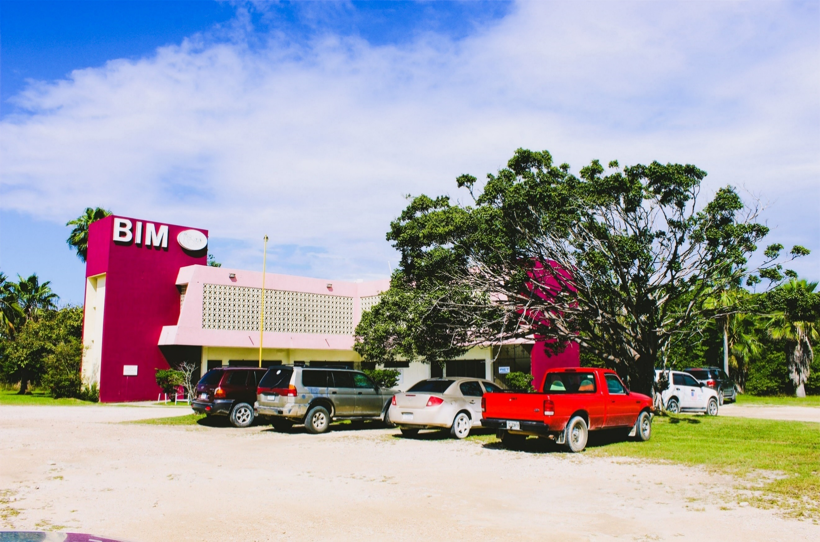
Call (223-3055), email (bimbelize@gmail.com), to register!
Visit our website at bimbelize.org.

