Upcoming Seminars Feb-Mar 2021  CREATING A PERSONAL ROADMAP  Feb.16 2021 11:30 AM - 12:30 PM $ FREE  ESSENTIAL JOB SKILLS THROUGH COVID-19 AND BEYOND  Mar.2 2021 11:30 AM - 12:30 PM $ FREE  LEADERSHIP COMPETENCIES TO SURVIVE A DISASTER  Mar.16 2021 11:30 AM - 12:30 PM $ FREE  BUILDING RESILIENCE THROUGH A CRISIS  Mar.30 2021 11:30 AM - 12:30 PM $ FREE | BIM PRE-REGISTRATION FORM  ORGANIZATION: ____________________________________________________________  ADDRESS: __________________________________________________________________  TELEPHONE: _________________ FAX: ___________________EMAIL: _______________  PARTICIPANTS BEING REGISTERED:  SEMINAR: __________________________________________________________________  NAME POSITION EDUCATION  ________________________ _________________________ __________________________  ________________________ _________________________ __________________________  ________________________ _________________________ __________________________  ________________________ _________________________ __________________________  SEMINAR: __________________________________________________________________  NAME POSITION EDUCATION  ________________________ _________________________ __________________________  ________________________ _________________________ __________________________  ________________________ _________________________ __________________________  ________________________ _________________________ __________________________  SEMINAR: __________________________________________________________________  NAME POSITION EDUCATION  ________________________ _________________________ __________________________  ________________________ _________________________ __________________________  ________________________ _________________________ __________________________  ________________________ _________________________ __________________________  __________________________  Signature  NOTE:  This form is to be returned to BIM as soon as possible along with $50.00 registration fee for each participant being registered.  This fee is non-refundable but is to be deducted from the total cost of the seminar when payment is made.
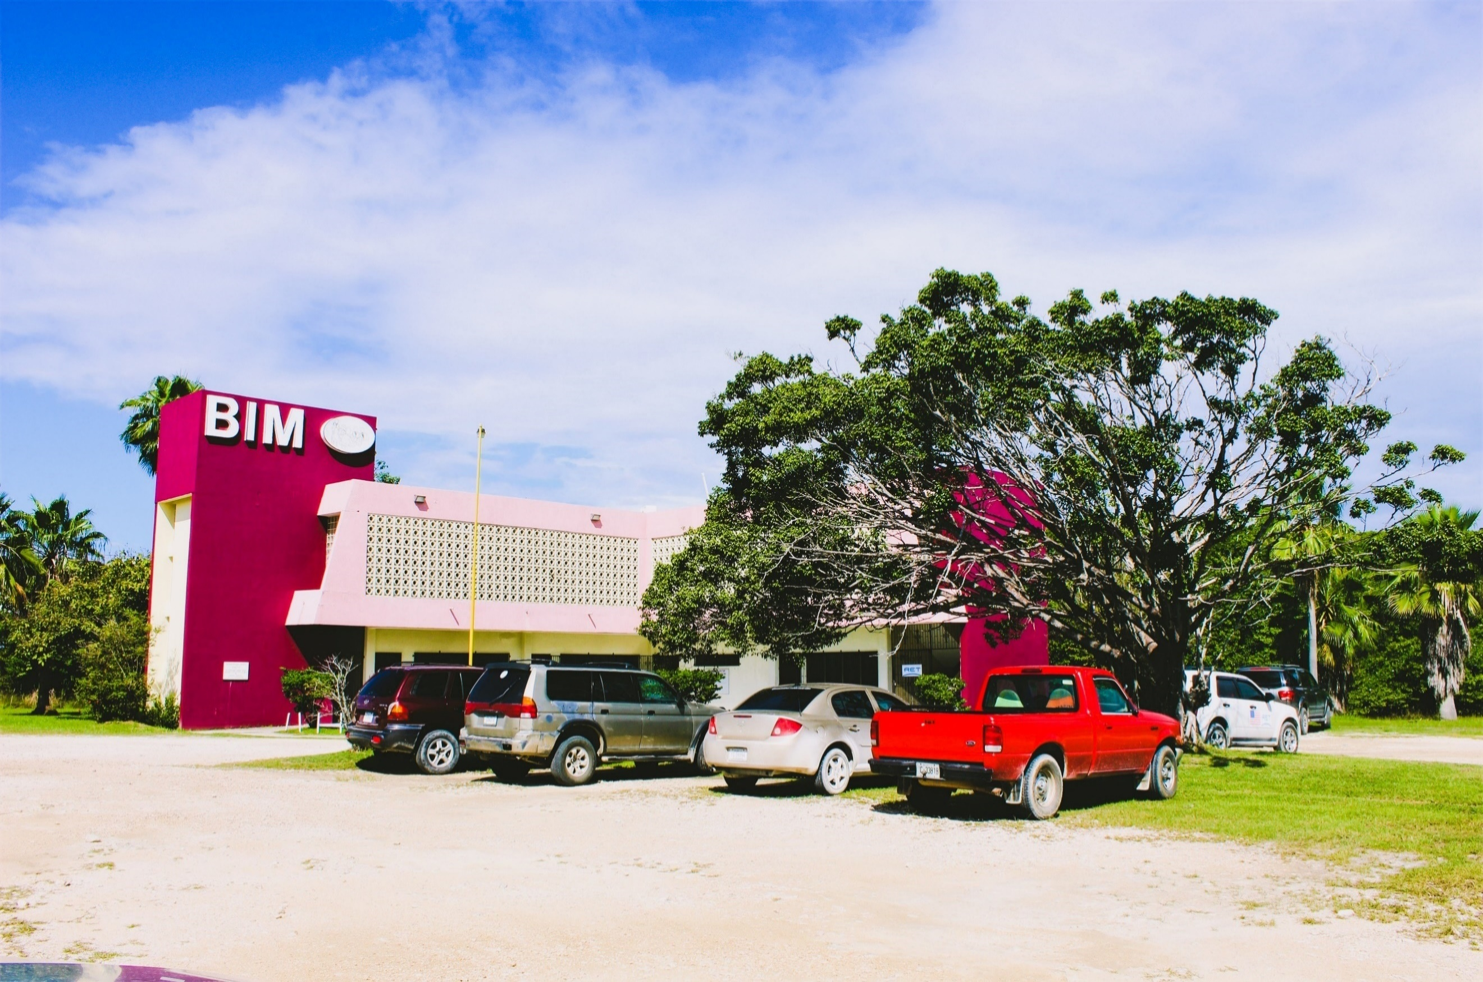
Call (223-3055), email (bimbelize@gmail.com), to register!
Visit our website at bimbelize.org.

